New Patient Intake Form

Title: (Circle one) ⁫ Mr. ⁫ Mrs. ⁫Ms. ⁫ Miss ⁫ Dr. ⁫ Other _______

First Name ___________________ Middle Initial ____ Last Name __________________________

Address ___________________________________________________________________________

City _______________________________ State ___________________ Zip Code ______________

Leave Messages on: (Circle one) Home Cell Work Don’t leave messages

Home Phone (_____) ________-___________ Work Phone (_____) _________-____________

Cell Phone (_____) ________-___________ Email ___________________________________

Date of Birth ______/______/_______ Sex: ⁫ Male ⁫ Female

Social Security Number: ______-_____-______ Marital Status: ⁫ Single ⁫ Married ⁫ Other

Employment Status: ⁫ Employed ⁫ Unemployed ⁫ FT Student ⁫ PT Student ⁫ Other_____

Employer Data ____

Employer _________________________________________________________________________

Your Occupation ___________________________________________________________________

Spouse Data________________________________________________________________________

First Name ________________________ Middle Initial ____ Last Name _____________________

Home Phone (_____) _______-__________ Work Phone (_____) _______-____________

Spouse Date of Birth _____/_____/_______

Emergency Contact_________________________________________________________________

Contact Name ____________________________ Relationship to Patient ___________________

Contact Home Phone (_____) _______-________ Cell Phone (_____) ________-______________

Doctor’s Signature ________________________________________

How did you hear about our office? ___________________________________________________

Medical Conditions: (Circle all that apply to you)
⁫ Arthritis ⁫ Cancer ⁫ Diabetes ⁫ Heart Disease
⁫ Hypertension ⁫ Psychiatric Illness ⁫ Skin Disorder ⁫ Stroke
⁫ Other ______________ Fibromyalgia Asthma Osteoporosis

Surgeries: (Circle all that apply to you)
⁫ Appendectomy ⁫ Cardiovascular procedure ⁫Cervical spine ⁫ Hysterectomy
⁫ Joint Replacement ⁫ Prostate ⁫ Lumbar spine ⁫ Gall Bladder
⁫ Brain ⁫ Shoulder ⁫ Thoracic spine ⁫ Knee
⁫ Carpal Tunnel ⁫ Gastro-intestinal ⁫ Uro-genital ⁫ Hernia
⁫Breast Augmentation Other ______________

Allergies: (Circle all that apply to you)
⁫ Mold ⁫ Seasonal ⁫ Milk or Lactose ⁫ Animal
⁫ Chemical ___________ Sulfites ⁫ Wheat/Glutens ⁫ Other _________

Social History: (Circle all that apply to you)
Caffeine use: ⁫ occasional ⁫ often ⁫ never
Drink Alcohol: ⁫ occasional ⁫ often ⁫ never
Exercise: ⁫ occasional ⁫ often ⁫ never
Drink Water: ⁫ <64 oz/day ⁫>64 oz/day ⁫ never
Cigarettes: ⁫<1 pack/day ⁫ >1 pack/day ⁫ never
Sleep: ⁫<8 hours/night ⁫ >=8 hours/night Insomnia ⁫
Other ________________

Family History: (Circle all that apply)
Arthritis: ⁫ Parent ⁫ Sibling
Cancer: ⁫ Parent ⁫ Sibling
Diabetes: ⁫ Parent ⁫ Sibling
Heart Disease ⁫ Parent ⁫ Sibling
Hypertension ⁫ Parent ⁫ Sibling
Stroke ⁫ Parent ⁫ Sibling
Thyroid ⁫ Parent ⁫ Sibling
Other _________________

Occupational Activities: (Circle one that best describes your job description)
⁫ Administration ⁫ Business Owner ⁫ Clerical/Secretary ⁫ Computer User
⁫ Heavy Equipment operator ⁫ Daycare/Childcare ⁫ Construction ⁫ Health Care
⁫ Food Service Industry ⁫ Medium Manual Labor ⁫ Manufacturing ⁫ Home Services
⁫ Heavy Manual Labor ⁫ Light Manual Labor ⁫ Executive/Legal ⁫ Housekeeper
⁫ Other ________________

Doctor’s Signature ________________________________________

Patient Name__________________________________________________Date___________________

Review of Systems – (Check box if you have had trouble with any of the following)

Cardiovascular |  |  | No | Respiratory |  |  | No | Allergic/Immunologic |  |  | No
 | Past | Present |  |  | Past | Present |  |  | Past | Present
Poor Circulation |  |  |  | Asthma |  |  |  | Hives
Hypertension |  |  |  | Tuberculosis |  |  |  | Immune Disorder
Aortic Aneurism |  |  |  | Short Breath |  |  |  | HIV/AIDS
Heart Disease |  |  |  | Emphysema |  |  |  | Allergy Shots
Heart Attack |  |  |  | Cold/Flu |  |  |  | Cortisone Use
Chest Pain |  |  |  | Cough
High Cholesterol |  |  |  | Wheezing
Pace Maker |  |  |  |  |  |  |  | Ear, Nose and Throat |  |  | No
Jaw Pain |  |  |  | Eyes |  |  | No |  | Past | Present
Irregular Heartbeat |  |  |  |  | Past | Present |  | Difficulty Swallowing
Swelling of legs |  |  |  | Glaucoma |  |  |  | Dizziness
 |  |  |  | Double Vision |  |  |  | Hearing Loss
Genitourinary |  |  | No | Blurred Vision |  |  |  | Sore Throat
 | Past | Present |  |  |  |  |  | Nosebleeds
Kidney Disease |  |  |  | Psychiatric |  |  | No | Bleeding Gums
Burning Urination |  |  |  |  | Past | Present |  | Sinus Infections
Frequent Urination |  |  |  | Depression
Blood in Urine |  |  |  | Anxiety |  |  |  | Gastrointestinal |  |  | No
Kidney Stones |  |  |  | Stress |  |  |  |  | Past | Present
Lower Side Pain |  |  |  |  |  |  |  | Gall Bladder Problems
 |  |  |  | Endocrine |  |  | No | Bowel Problems
Neurologic |  |  | No |  | Past | Present |  | Constipation
 | Past | Present |  | Thyroid |  |  |  | Liver Problems
Stroke |  |  |  | Diabetes |  |  |  | Ulcers
Seizures |  |  |  | Hair Loss |  |  |  | Diarrhea
Head Injury |  |  |  | Menopausal |  |  |  | Nausea/Vomiting
Brain Aneurysm |  |  |  | PMS |  |  |  | Bloody Stools
Numbness |  |  |  |  |  |  |  | Poor Appetite
Severe Headaches |  |  |  | Hematologic |  |  | No
Pinched Nerves |  |  |  |  | Past | Present |  | Musculoskeletal |  |  | No
Parkinson’s |  |  |  | Hepatitis |  |  |  |  | Past | Present
Carpal Tunnel |  |  |  | Blood Clots |  |  |  | Gout
Vertigo |  |  |  | Cancer |  |  |  | Arthritis
 |  |  |  | Bruising |  |  |  | Joint Stiffness
Constitutional |  |  | No | Bleeding |  |  |  | Muscle Weakness
 | Past | Present |  | Fever, Chills |  |  |  | Osteoporosis
 |  |  |  | Sweating |  |  |  | Broken Bones
Weight Loss/Gain |  |  |  | Varicose Vein |  |  |  | Joints Replaced
Low Energy Level |  |  |  |  |  |  |  | Neck Pain
Difficulty Sleeping |  |  |  |  |  |  |  | Low Back Pain
 |  |  |  |  |  |  |  | Upper Back Pain
Please list all current medications being taken ________________________________________________
_____________________________________________________________________________________
How are your symptoms changing? Getting better Not changing ⁫ Getting worse

Are You Pregnant? (Circle) Yes No

Doctor’s Signature ________________________________________

Patient Name_____________________________________________Date_____________________

By Using the key below, indicate on the body diagram where you are experiencing the following symptoms:
N=Numbness B=Burning S=Sharp T=Tingling A=Dull Ache
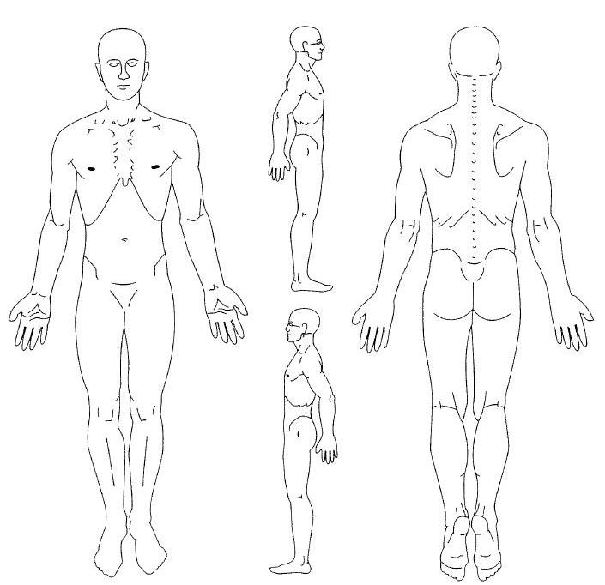
Average Pain Intensity:
Last 24 hours: no pain 0 1 2 3 4 5 6 7 8 9 10 worst pain
Past week: no pain 0 1 2 3 4 5 6 7 8 9 10 worst pain
Does anything improve your pain? Yes No If Yes, please list:

When did your symptoms begin? ________________________________________________

Are your symptoms a result of: ⁫ Motor Vehicle Accident ⁫Work related Accident ⁫ Other_____

How did your symptoms begin? _________________________________________________________
_____________________________________________________________________________________

How often do you experience your symptoms?
⁫ Constantly ⁫ Frequently ⁫ Occasionally ⁫ Intermittently
(76-100% of the day) (51-75% of the day) (26-50% of the day) (0-25% of the day)

What describes the nature of your symptoms?
⁫ Sharp ⁫ Ache ⁫ Numb ⁫ Shooting
⁫ Burning ⁫ Tingling ⁫ Throbbing ⁫ Other ______

Doctor’s Signature ________________________________________

Patient Name_______________________________________________Date______________________
FAMILY SPORT AND SPINE
PAYMENT POLICY

Thank you for choosing Family Sport and Spine as your Chiropractic provider. We are committed to providing you with quality and affordable health care. Due to some of the questions our patients have regarding patient and insurance responsibility for services rendered, we have been advised to develop this payment policy. Please read it, ask any questions you may have, and sign in the space provided below. A copy will be provided to you upon request.

- INSURANCE. We participate in most insurance plans, including Medicare. If you are not insured by a plan we participate with, payment in full is expected at each visit. If you are insured by a plan we do participate with, but do not have an up-to-date insurance card, payment in full for each visit is required until we can verify your coverage. Knowing your insurance benefits is your responsibility, please contact your insurance company with any questions you may have regarding your coverage. If your insurance company requires a referral it is your responsibility to provide us with a referral dated the day of your first visit from your primary care physician prior to your first visit. We are only able to provide a summary of your chiropractic benefits.
- CO-PAYMENT AND DEDUCTIBLES. All co-payments and deductibles must be paid at the time of service. This arrangement is part of your contract with your insurance company. Failure on our part to collect co-payments and deductibles from patients can be considered fraud. Please help is in upholding the law by paying your co-payment at each visit.
- PROOF OF INSURANCE. All patients must complete out patient information form before seeing the provider. We must obtain a copy of your most current insurance card to provide proof of insurance. If you fail to provide us with the correct insurance information in a timely manner, you may be responsible for the balance of a claim.
- CLAIM SUBMISSION. We will submit your claims and assist you in any way we reasonably can to help get your claim paid. Your insurance company may need you to supply certain information directly. It is your responsibility to comply with their request. Please be aware that the balance of your claim is your responsibility whether or not your insurance pays your claim. Your insurance benefits are a contract between you and your insurance company; we are not party to that contract.
- CONVERAGE CHANGES. If your insurance coverage changes, please notify us before your next visit so we can make the appropriate changes to help you receive your maximum benefits. If your insurance company does not pay your claim in 90 days, the balance will automatically be billed to you.
- MISSED APPOINTMENT. Our policy is to charge $25.00 after one missed appointment not cancelled 24 hours in advance. The charges will be your responsibility and billed directly to you. Please help us to serve you better by keeping your regular scheduled appointment.
Our practice is committed to providing the best treatment to our patients. Our prices are representative of the usual and customary charges for our area.

I have read and understood the payment policy and agree to abide by its guidelines.

______________________________________ _____________________
Signature of patient or responsible party Date

